AJC Preliminary Examination 2012
H2 Mathematics Paper 1 (9740/01) Solution
Qn | Soln
1 | 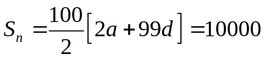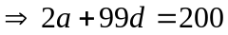  a, a+d, a+4d are consecutive terms in GP: 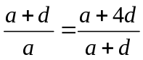  ⇒ (a+d)² = a(a+4d)  ⇒ d² = 2ad ⇒ d = 2a since d ≠ 0 .  Sub d = 2a into 2a + 99 d = 200, get d = 2 and a = 1.
2 | 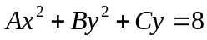 (2,1) ⇒ 4A + B + C = 8 -----(1)  Diff (*) wrt x : 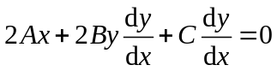 ⇒ 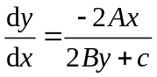  Tangent at (2,1) // y-axis : 2B + C = 0 ------(2) [1]  Diff again wrt x :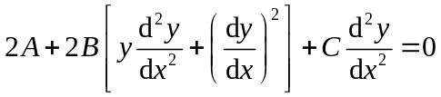  When y = 0 , 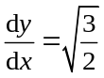 and 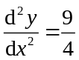 ⇒ 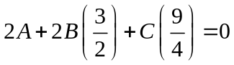 (3)  Solve the 3 eqns : get A = 3, B = 4 and C = -8
3 | ⇒ 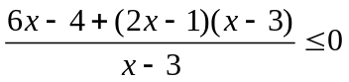 ⇒ 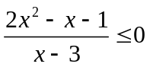 ⇒ 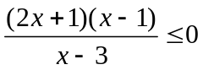  ⇒ 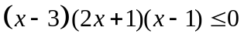  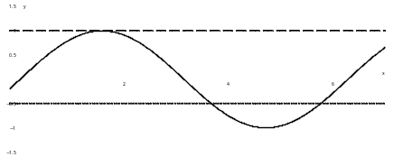  ⇒ 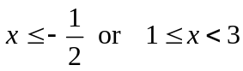  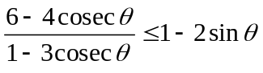 ⇒ 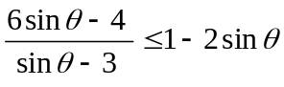  Replace x by sinθ , 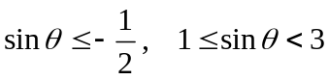  ⇒ 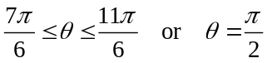
4  (i) | Reversing the transformations:  - Stretch parallel to y-axis by factor ½ gives 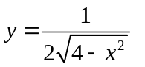  - Translate 1 unit to the right gives 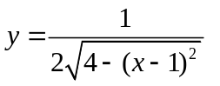  - Reflection in y-axis gives 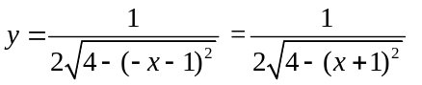= f(x)
4  (ii) | 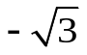  The graphs of y = g(x) and y = g⁻¹(x):  y = g(x)  y = g⁻¹(x)  -2  -2  ½  ½  x  y  B  1  1  A
4  (iii) | area of the region bounded by y = g⁻¹(x), the x-axis and the line x = 1 = region A = region B  = Rectangle - 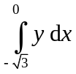  = 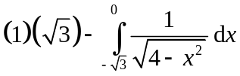 =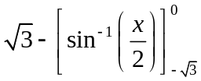 = 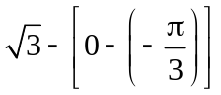 =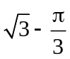.
5 | 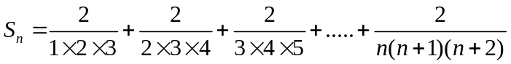  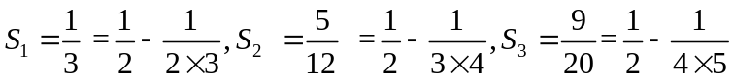.  (ii) =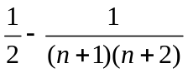 by observation.  (iii) Let 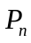 be the statement “=” for 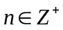  P₁ is true from (i)  Assume that 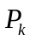 is true for some 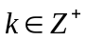 ie. 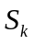=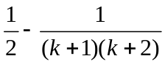  We need to show that 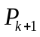 is true, ie to prove that 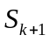=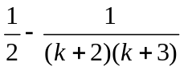  LHS = = + (k+1)th term  = + 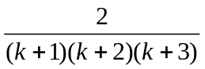  = 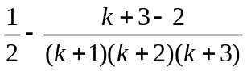  = = RHS  Therefore is true.  Since 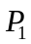 is true and is true 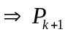 is true, by MI, is true for
6 | (i) By pythagoras’ theorem: 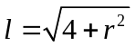 and 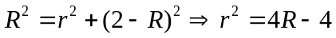  A = 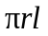 ⇒ A = 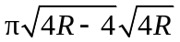  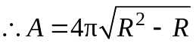  (ii) 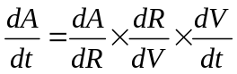  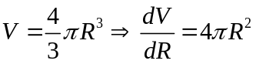  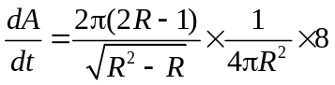  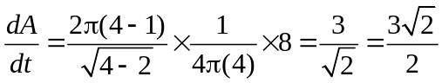
7 | (i) Since the sequence converges to L,  ie as 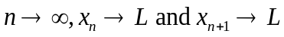 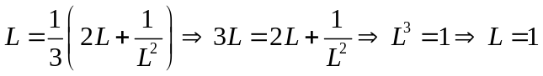  - Consider 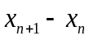=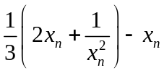  Method 1: = 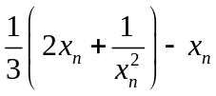 = 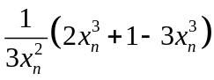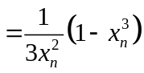  Since 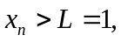 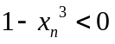 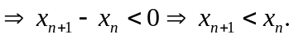  y  y  y  1  Method 2: Use GC, sketch 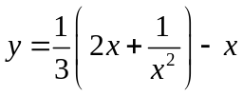  From the graph, for  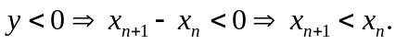  - The sequence is such that 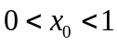, and from (i) 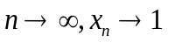.  From (ii) , 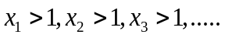and 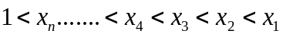  the sequence will decrease and converge to the limit 1 from the right for 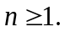  Since L =1, 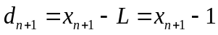  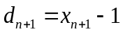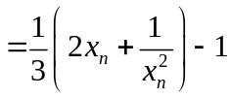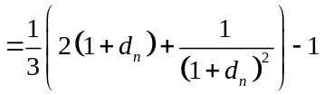  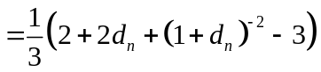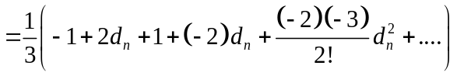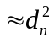  Range of validity is 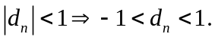
8a | 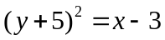 -----(1) 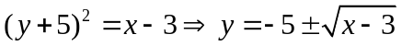  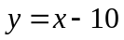 -----(2)  Points of intersections are 4, -6) and (7, -3)  Volume generated  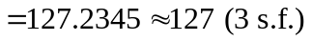
8b | 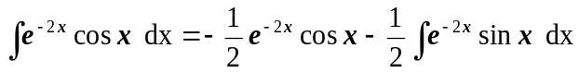    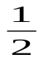  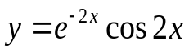  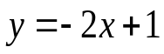  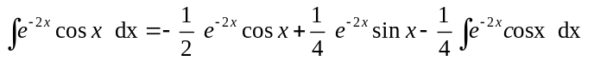  y  0  x  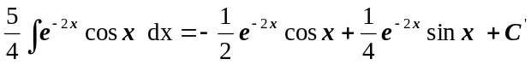  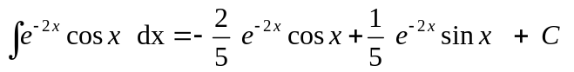  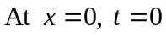. 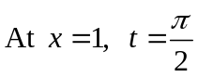  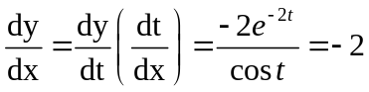  Equation of tangent at x = 0: 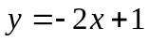  Exact area bounded  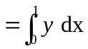 *(Since the area of both triangles are the same)  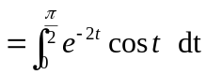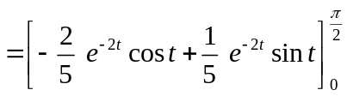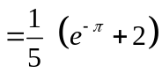
9 | (i) 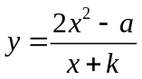 ⇒ 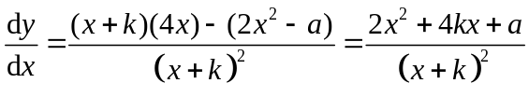  For the curve to have at least 1 tangent parallel to the -axis, 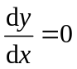 must have real roots,  i.e. 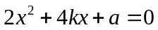 has real roots  Since 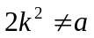, 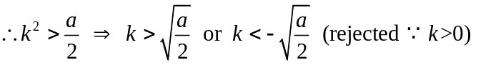  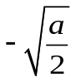  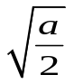  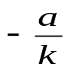  -k  y=2x-2k  (ii) 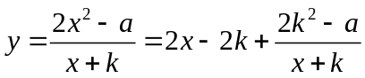  When 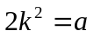, 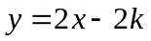  Thus, the graph is a straight line.  (iii)  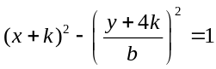  From diagram, 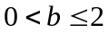
10  (i) | (i) A(0,1,0) lies on p₂: 8(0)+a(1) + (0) = 4 hence a = 4.  Director vector of L :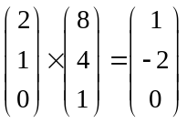 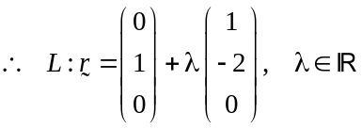
10  (ii) | (ii) 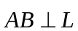 and 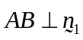  ⇒ 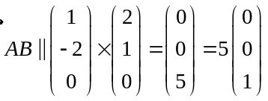. Hence 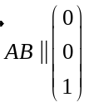  P₂  A  B  C  P₁  5  n₂  2nd part: Method 1  Let 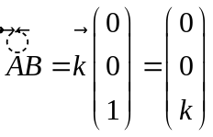 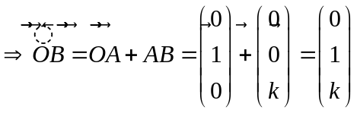  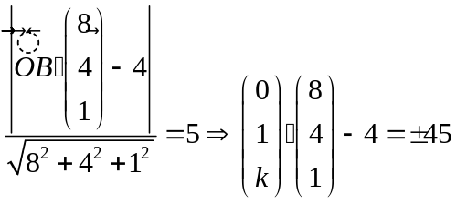 ⇒ 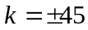. 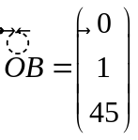 or 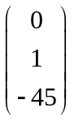  Method 2  BC = 5 = length of projection of 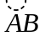onto 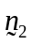  = 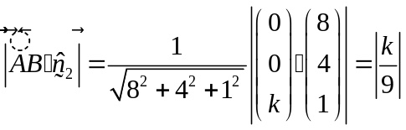.  Hence 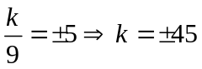 .  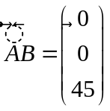 or 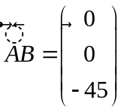  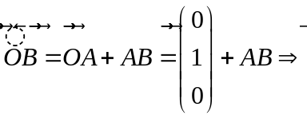. or
10  (iii) | Method 1 :  Acute angle between line AB and p₂  = acute angle between p₁ and p₂ = 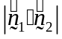  = 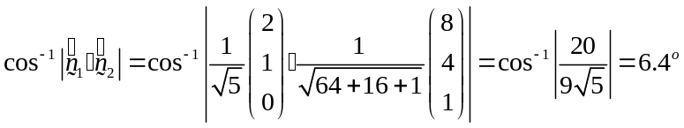  Method 2 :  acute angle between line AB and p₂  = 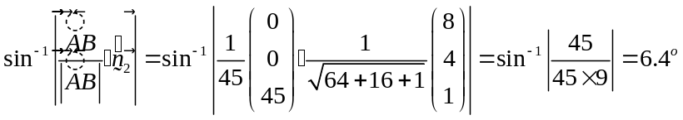
10  (iv) | p₃ : 2x+ y +βz = 6 .  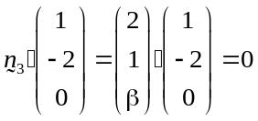 for all values of β.  Hence p₃ // L ----(1)  2(0) + 1+β(0) = 1 ≠6 ⇒ A(0,1,0) does not lie on p₃ -----(2)  Hence line L does not intersect p_{3.} Therefore p₁, p₂ and p₃ do not meet at a common point.  When β = 0,  p₃ : 2x+ y = 6 , p₁ : 2x + y = 1 , p₂, 8x +4y + z =4  Geometrically, p₁ and p₃ are parallel with p₂ intersecting both p₁ and p_{3.}

11 | Angle that locus of Z makes with the real axis = 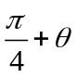.  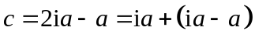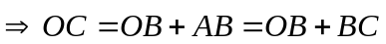  Geometrical relationship: AC is the diameter of the circle with centre B.  [Or A, B, C are collinear; Or B is the midpt of A and C]  (i) 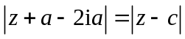= Distance between Z and C. Least 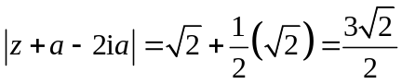  (ii) 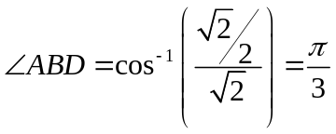 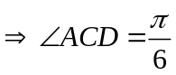  Acute angle CA makes with the real axis = 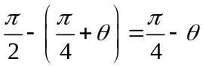  Largest   